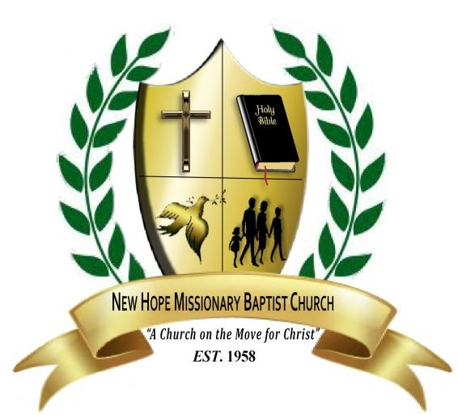**NEW HOPE MISSIONARY BAPTIST CHURCH**

Rev. Dr. John E. Cotten, Jr. | Senior Pastor

Rev. Dr. Danielle Cotten | Assistant Pastor

**ENGAGEMENT REQUEST**

***Rev. John E. Cotten, Jr.***

Please complete this request for your upcoming engagement. Please note that this form **IS NOT** a confirmation and is a **REQUEST ONLY**. Please allow **two (2) to three (3) business days** after the receipt of the request for confirmation, as the Pastoral Calendar will need to be reviewed.

All questions and concerns can be forwarded to the Pastoral Administrator, Sis. Danica L. Blue via email Danica.blue@cottens.org

**Name of Church**:

**Pastor’s Name:**

**Contact Person’s Name**:

**Contact’s Email address**:

**Phone Contact: Day Time:** ( ) **Cell Phone**: ( )

**Church Street Address (No P.O. Boxes, please**):

**City: State:** __ **Zip**__

**Date(s) of Engagement:**

**Time of Engagement:**

**Engagement Type**: ___

(Youth Conference, Concert, Convocation, Etc.)

**Name of Church/Venue of Event (if different from above):**

**Location of Event (if different from above**)

**City** **State Zip Code**

**Seating Capacity**___________ **Number of persons expected to attend**_________________

**Will there be marketing for the engagement, if so please provide a brief marketing summary**. **Will a photograph and/or biography be needed?**

**Are you requesting the New Hope Choir to accompany Pastor Cotton to the engagement?**

**YES [ ] NO [ ]**